Year 4 Term Overview Spring

**LITERACY**

In Literacy we will be reading The Three Musketeers by Alexander Dumas. The children will use skills of inference and deduction to explain what has happened in the story and why a character might behave in a certain way. The children will write a letter as D’Artagnan explaining why they would make a good Musketeer and will describe a battle scene! We will also investigate features of Poetry creating an acrostic poem about Europe. Additionally, the children will create a travel brochure encouraging people to visit Europe.

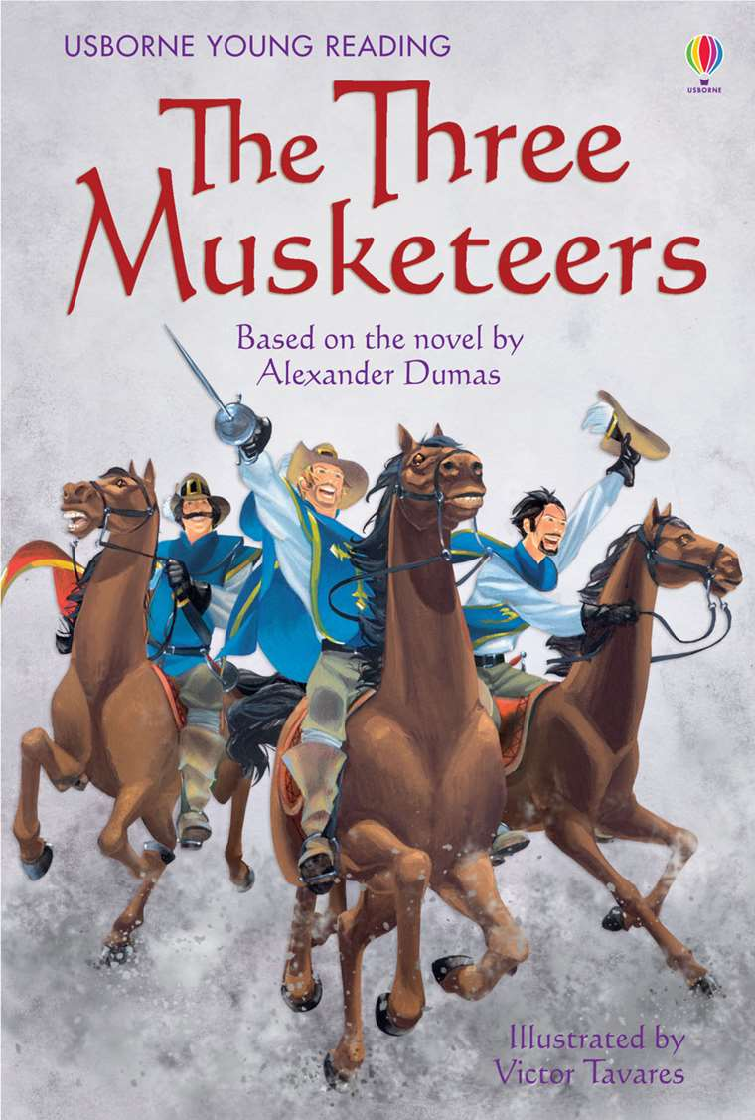

**Computing**

I computing the children will be focussing on programming becoming a coder. They will use Purplemash programs to investigate what coding is and how to write an algorithm. Please encourage your children to use the computing section on PurpleMash to practise their skills.

The children will continue to learn about E-Safety.

**Home Learning**

Homework will be given on a Friday and will be due in the following Wednesday. Please encourage your child to complete their work to the best of their ability and practise their times tables and reading. If you ever have a need to speak to either Mr Field or Mr Groves please feel free to see us after school.

**TOPIC**

Our topic is Backpacking around Europe, a topic based on the differences between the UK and Europe. We will investigate important European landmarks and will learn about significant people and events within Europe. Finally, the children will eventually consider how life in Britain is different to life in a European country.

**PE**

P.E will be on Thursday afternoon that will start back on Thursday 10th January. In addition, this term the children will be starting swimming on Monday 14th January for the full term. Please ensure that all your child’s clothing is fully labelled and that they have a swimming hat and suitable swimming bag.

**SCIENCE**

Our science topics will be electricity. The children will learn to use scientific vocabulary when describing electricity. They will learn how to make an electric circuit and will be learning about the dangers of electricity and how to stay safe. Finally, they will investigate and experiments with how electricity travels through a circuit.

**MATHEMATICS**

Year 4 will continue to build on a wide range of mathematical skills this term. The children will learn about fractions, including adding and subtracting fractions with the same denominator. They will also be looking at converting decimals to fractions. The children will develop their skills and knowledge of by learning about the passing of time. Children will continue to build on their multiplication and division skills through the online program TT Rock Stars. Please encourage your children to use TT rock stars at home.