Key Stage 2 SATS’s Results Summer 2016
 | Reading, Writing, Maths Combined |  |  | Maths |  |  | Reading |  |  | Writing |  |  | English Grammar Punctuation & Spelling
 | Number of children | School  % | National  % | Number of children | School  % | National  % | Number of children | School  % | National  % | Number of children | School  % | National  % | Number of children | School  % | National  %
Pupil Premium Children | 9/27 | 33% | 60% | 16/27 | 59% | 75% | 9/27 | 33% | 71% | 15/27 | 56% | 79% | 18/27 | 67% | 78%
All Children | 23/60 | 38% | 53% | 36/60 | 60% | 70% | 23/60 | 38% | 66% | 38/60 | 63% | 74% | 37/60 | 62% | 72%

MATHS
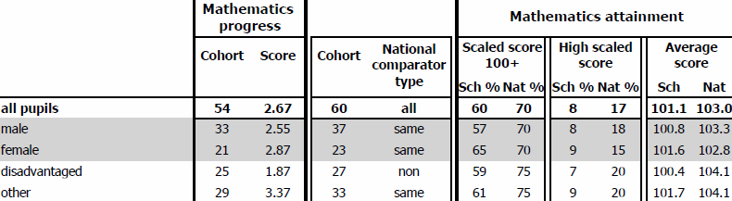

Writing
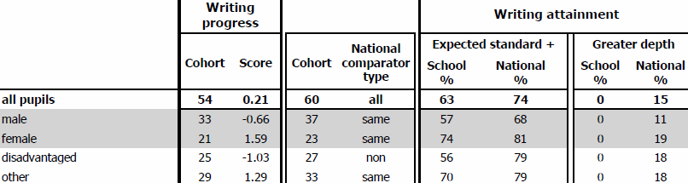
Reading
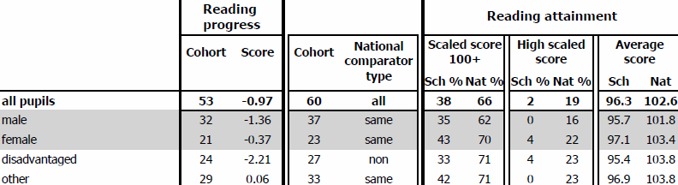
Spelling, Punctuation and Grammar
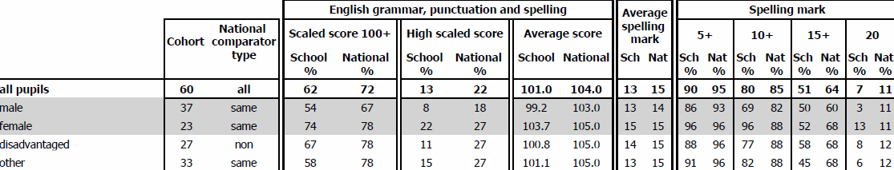

Key Stage 1 SATS’s Results Summer 2016

 | Maths |  |  | Reading |  |  | Writing
 | Number of children | School  % | National  % | Number of children | School  % | National  % | Number of children | School  % | National  %
Pupil Premium Children | 30 | 63% | 77% | 30 | 60% | 78% | 30 | 72% | 65%
All Children | 60 | 80% | 73% | 60 | 75% | 74% | 60 | 53% | 70%

